MPA 634  
Data Science for Managers  
Midterm II: Winter 2020

# I. Definitions and Concepts

1. First explain how lists are used in R and then explain the function of the $ notation. Why does mpg$hwy give the highway data from the mpg tibble.
2. Use an example to explain the difference between and long and wide tibbles.
3. Compare and contrast a left-join with an inner join. Construct an example using two different hypothetical tibbles to illustrate your answer.
4. First define factors and explain what is meant by a factor's level and label.
5. Explain the relationship between the cut function and if else conditional execution.

# II. Code Interpretation

Code Chunk I: Interpret lines 3 - 7

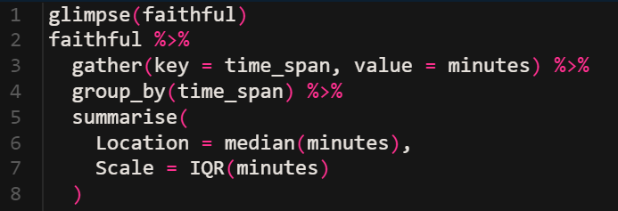

Code Chunk II: Interpret lines 4 - 7

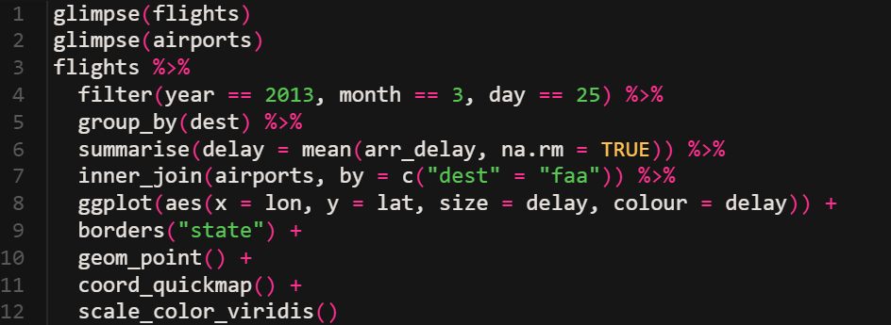

Code Chunk III: Interpret lines 1-2 and 5 - 6

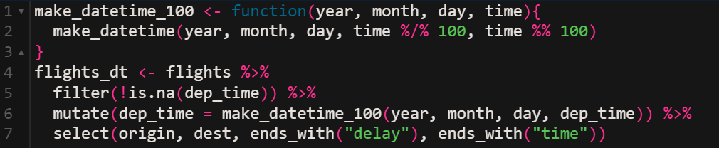

Code Chunk IV: Interpret lines 1 – 6 and 9

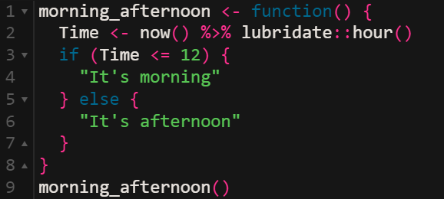

Code Chunk V: Interpret all lines

